AD006 COSC 2534
Operating System Administration
Skills Exam 2

First Name: | Vu
Last Name: | Nguyen
Student ID: | s4010423

Pre-requisite
Task 1 :
You must have available two 2x Windows Server’s Machine and 1 Windows Client Operating Systems Virtual Machines with VirtualBox Guest Additions installed and turn firewalls off respectively.
Points to be noted for this skill test is as follows:
- Create the same three VMs with the same hardware specifications.
- Install Windows server 2019/2022 (Data-center evaluation) for Server 1 and Server 2.
- Install windows 10/11 (Pro or enterprise) for the client.
- Use the password Rmit1234! For all the three VMs
- Use internal network Adaptor for all the three VMs with the same settings.
- Install guest editions in all the three VMs.
- Turn off the windows firewall in all the three VMs.
- Configure the following IP setting for all the three VMs
Server1 IP: 192.168.80.30 Server2 IP: 192.168.80.60
Default Gateway 192.168.80.1 Default Gateway 192.168.80.1
Preferred DNS server: 192.168.80.30 Preferred DNS server: 192.168.80.30

Client IP: 192.168.80.90
Preferred DNS server: 192.168.80.30

Ping from Server1 to Server2 and Client.

Ping from Server2 to Server1 and Client.

Ping from Client to Server1 and Server2.
- Set the computer names of the Three VMs ( Win2019/2022primary , Win2019/2022secondary , win10/11client)
- Install ADDS and DNS at the same time in server 1
- Promoting Server1 to be Domain Controller with DNS and GC for the Domain named as SkillsCOSC2534.com
- Join server 2 to the Server 1 domain.
- Join Client VM to the server 1.

[Take Screenshots for completing the points above] -- 5 Marks

NOTE: if you have completed Task 1 in week 14 for this Assessment , you will be awarded 5 bonus Marks.

Task 2 Distributed File System on Server1 and Server2

- Install Distributed File System DFS Role on Server1 and Server2

[Screenshots DFS Role installed on Server1 and Server2] below - 2 marks
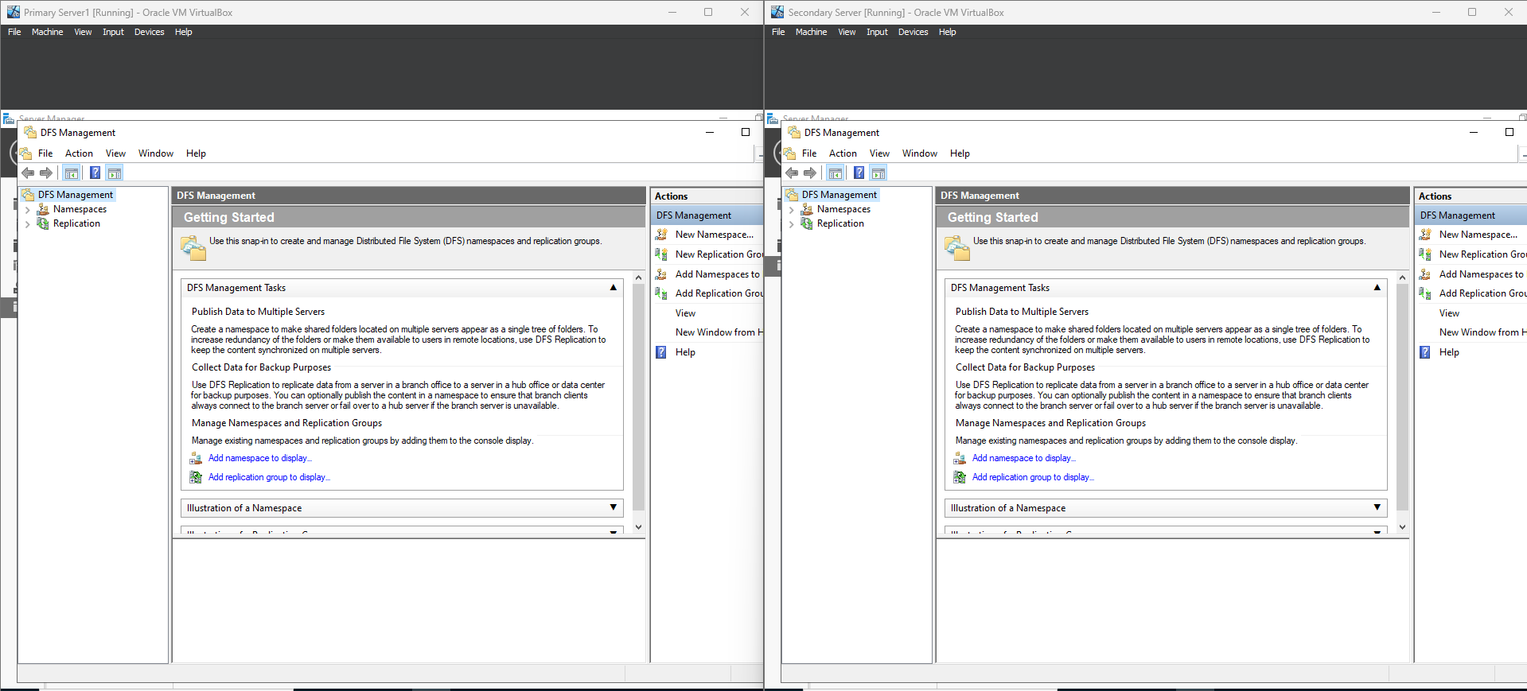
- Configure DFS Namespace on Server1
DFS Namespace - DFS<Lastname>
Namespace Type – Domain-based

Please note: Inside the DFS namespace location, you must create the target Folder named DFSFiles

[Screenshots DFS Namespace on Server1] below - 2 marks

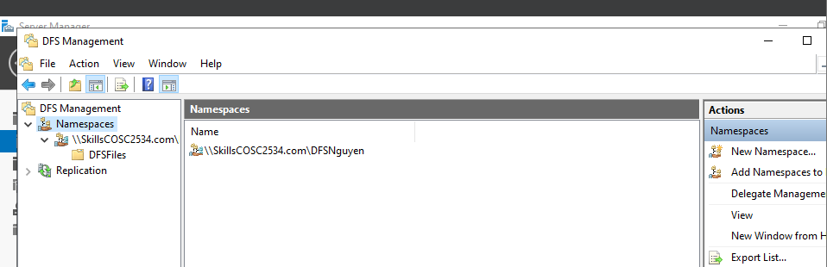

- Install DFS Replication on Server1 and Server2

[Screenshots DFS Replication installed on Server1 and Server2] below - 2 marks

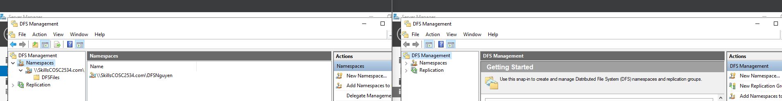
- Configure DFS Replication on Server1 and Server2
Target Folder in the namespace location – DFSFiles
Replication Group - S1andS2
Primary Member – Server1
Please note: Inside the DFS namespace location , you must create the target Folder named DFSFiles

[Screenshots Replication Properties on DFS Management for both the servers] below - 4 marks
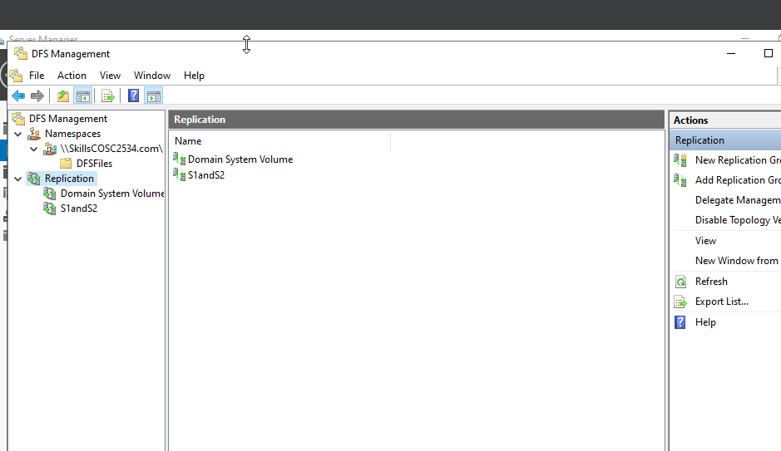
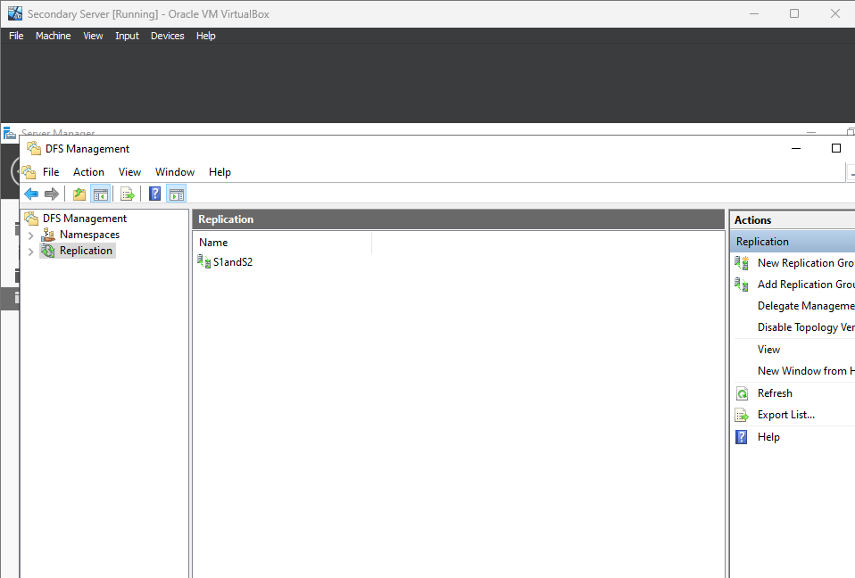

Task 2 Total = A(2) + B(2) + C(2) + D(4)= 10 marks.

Task 3 Virtual Private Network on Server1 and connections on Windows Client

- Install VPN Server on Server1

[Screenshots Routing and Remote Services with VPN Setting] below - 2 marks
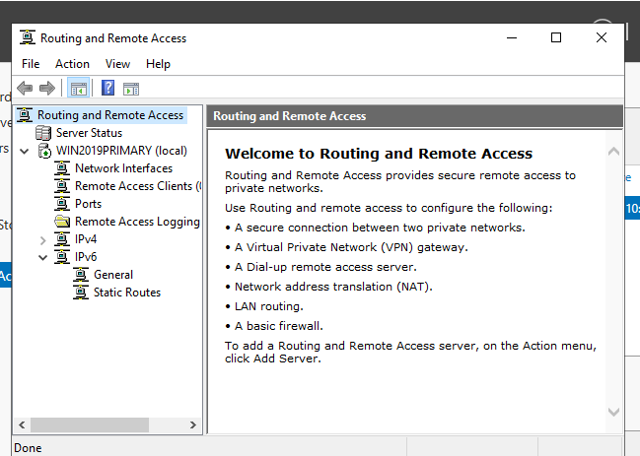

- Create and Allow domain user VPNUser to access VPN

[Screenshots VPNUser Properties] below 1 mark
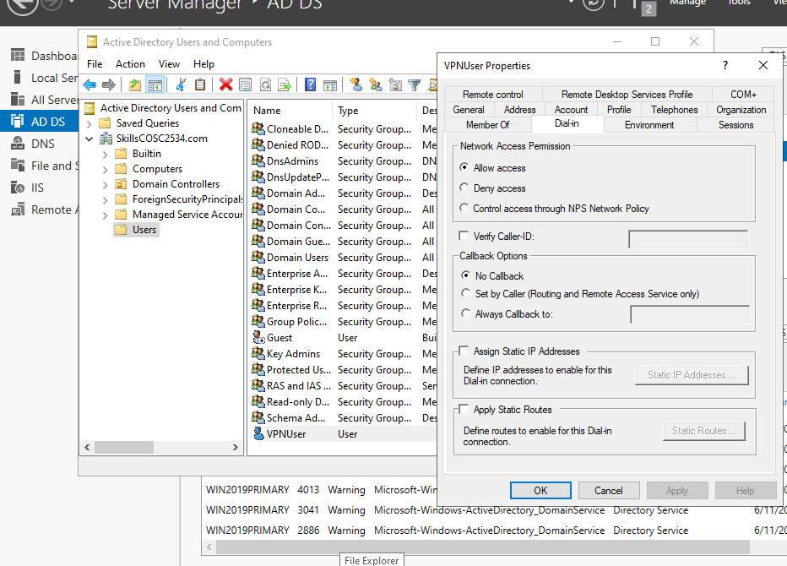

- On Windows Client, setup VPN connection using PPTP
Connection Name - <Firstname>PPTP
Configure VPN Server for Static Address Pool starting 192.168.80.100 and ending with 192.168.80.150 .

[Screenshots PPTP Network connection, assigned VPN Client IP Configurations and ping from
Server1] below 4 mark
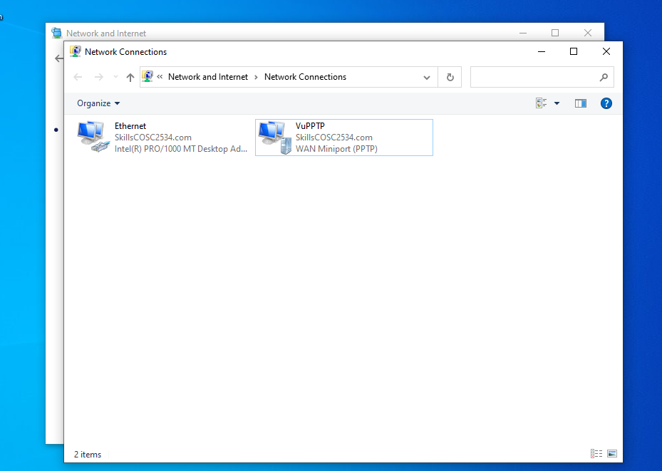

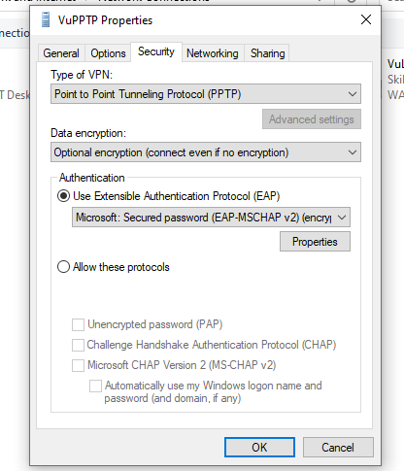
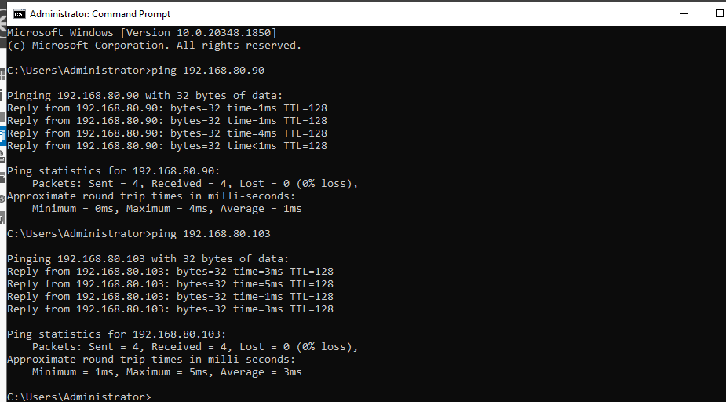
- On Windows Client, setup VPN connection using L2TP
Connection Name - <Firstname>L2TP
Preshared Key for Authentication - <Firstname>
Configure VPN Server for Static Address Pool starting 192.168.80.200 and ending with 192.168.80.250

[Screenshots L2TP Network connection, assigned VPN Client IP Configurations and ping from Server1] below 4 marks
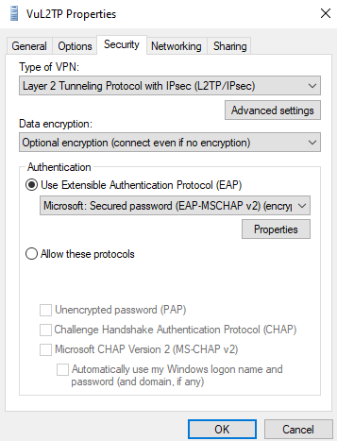
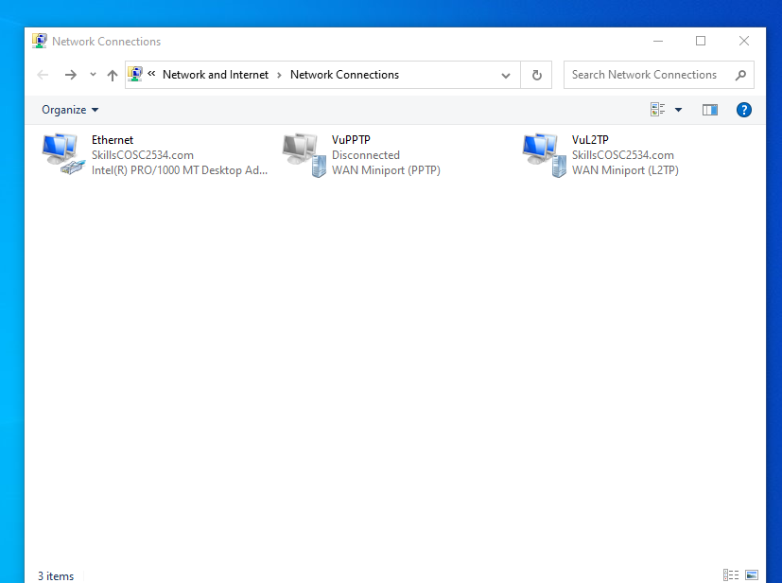
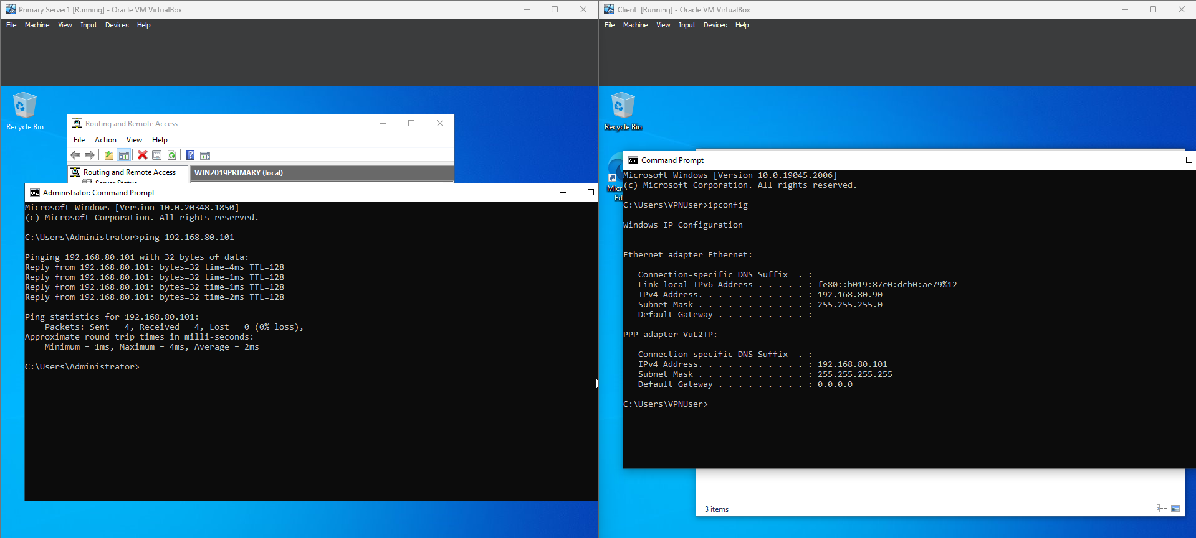
Task 3 Total = A(2) + B(1) + C(4) + D(4) = 11 marks.

Task 4 PowerShell

Using Server1, you are required to obtain from Canvas the required files ADUsers_Add.ps1 and ADUsers_List.csv. All Tasks need to be executed in PowerShell cmdlets and to be screenshots.

- Creates 3 Aliases Cat -> Get-Alias, Dog -> Get-date and Lamb -> Get-ChildItem

[Screenshots Using one of the aliases to display Created Aliases] below 3 marks
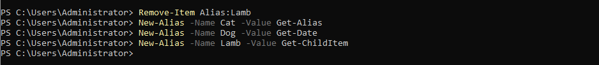
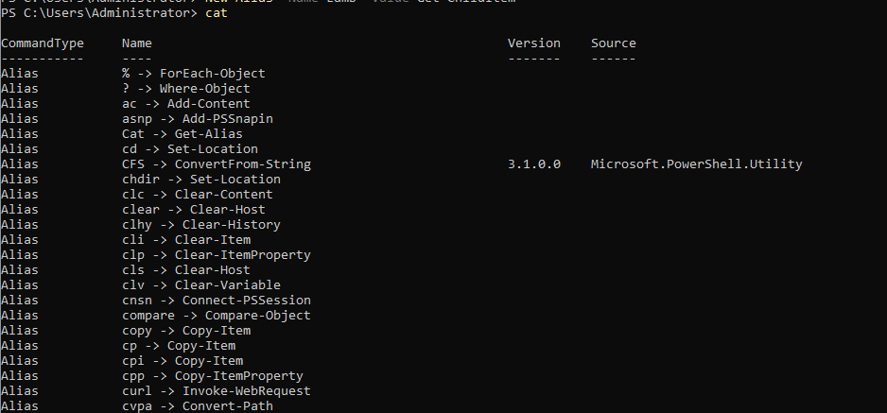
- Show the result of executing “Dog Cat Lamb”.
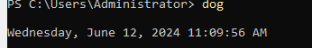
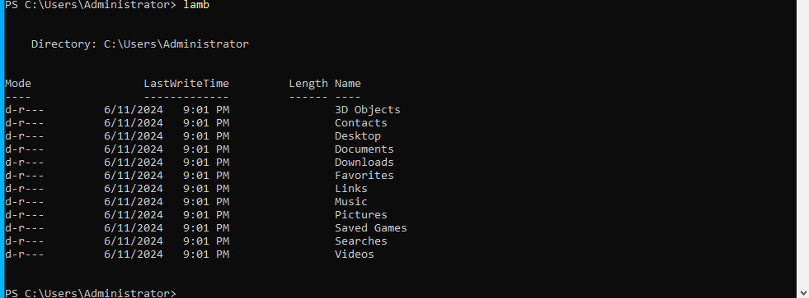
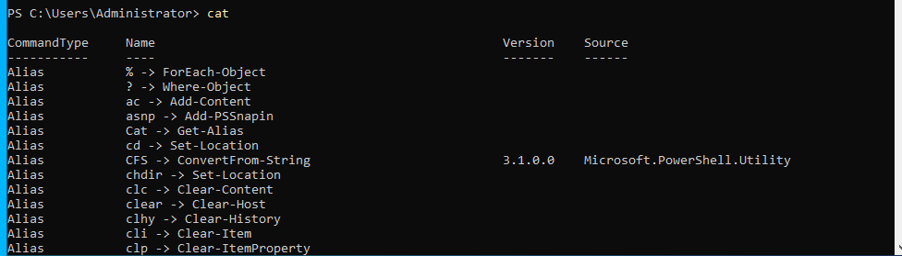
[Screenshots your result by Using one of the alias] below 2 marks
- Create an OU “SystemAdministration” within an OU “ICT” in your Domain, for example SkillsCOSC2534.com
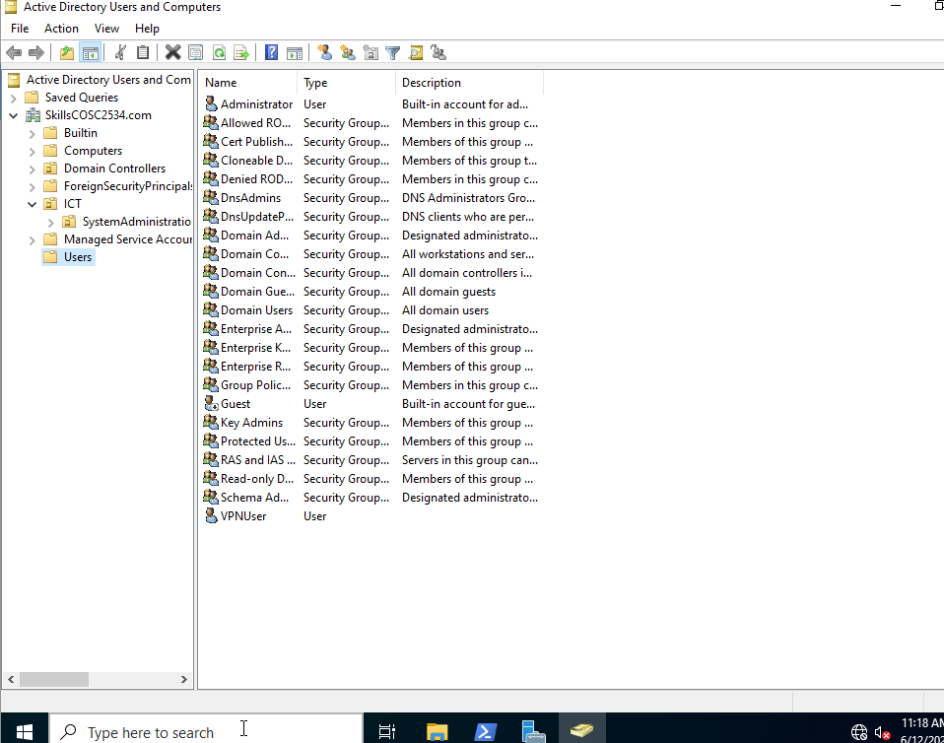
[Screenshots Creation by PowerShell and verified by Active Directory Users and Computers] below 2 marks
- Edit ADUsers_Add.ps1 and ADUsers_List.csv, do modifications to get it automating adding users to NestedOU in the Active Directory.

[Screenshots of Edited ADUsers_Add.ps1, ADUsers_List.csv and verified Users Added by Active Directory Users and Computers] below 4 marks

Task 4 Total = A(3) + B(2) +C(2) + D(4) = 11 marks.

Task 5 Short Answer Questions (Week 11 to week 13)

Question 1: Create a new user account using PowerShell cmdlet with the following attributes:
Note: Please use your name as my name is only example
Note: You can use the domain name AD006.local
Name Geetu Sharma
Given Name Geetu
Surname Sharma
Account Name G.sharma
User Principal Name g.sharma@AD006.local
Password input
Status Enabled
New-ADUser -Name "Vu Nguyen" -GivenName "Vu" -Surname "Nguyen" -SamAccountName "V.nguyen" -UserPrincipalName "v.nguyen@SkillsCOSC2534.com" -AccountPassword (Read-Host -AsSecureString "Enter Password") -Enabled $true

Question 2. List three differences between IKEv1 and IKEv2.
Protocol and Flexibility: IKEv1 uses two phases for negotiation, while IKEv2 combines these into a single exchange, making it more efficient. Additionally, IKEv2 is more flexible in terms of supporting multiple authentication methods and handling network address translation (NAT) traversal.

Mobility and Multihoming: IKEv2 includes support for mobile devices and networks with built-in support for handling changes in IP addresses and network connections, making it more suitable for scenarios involving mobility and multihoming.

Security Enhancements: IKEv2 offers improvements in security, including stronger cryptographic algorithms and more robust mechanisms for handling denial-of-service (DoS) attacks. It also provides better support for certificate-based authentication and simplifies the management of cryptographic keys.

Question 3. What is the command you type to view all the users in Active directory using PowerShell?
Get-ADUser -Filter *

Question 4: Explain 3 protocols, you use to ensure secure communication over a VPN?

IPsec: Encrypts and authenticates IP packets, ensuring secure communication between VPN endpoints at the network layer.

SSL/TLS: Encrypts data between the client and server, commonly used for remote access VPNs via web browsers or dedicated clients, providing security at the application layer.

L2TP/IPsec: Combines L2TP for tunneling with IPsec for encryption and authentication, suitable for various VPN scenarios including site-to-site and remote access, offering a balance of security and compatibility.

Question 5: What is the cmdlet that you use if you want to create a new file in PowerShell?

New-Item -ItemType File -Path "C:\Path\to\your\file.txt"

Task 5: Question 1 (6) + Question 2 (3) + Question 3 (1) + Question 4 (3) + Question 5 (1)

Grand Total = Task 2 (10) + Task 3 (11) + Task 4 (11)+ Task 5 (14)
= 46 Marks.

